**5…4…3…2…1…**

**BLAST OFF!**

**Discovering Our Solar System:**

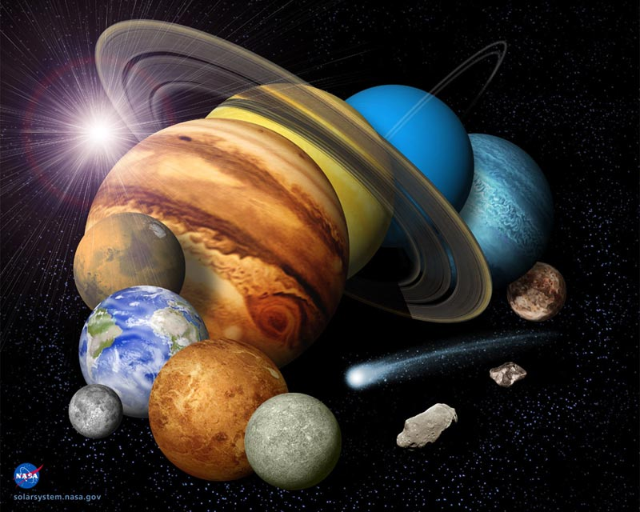

This WebQuest is designed is take 8th graders on an intergalactic, planetary journey where they will become true explorers of space!

Created By: Catlin Gross

C:\Users\Catlin\AppData\Local\Microsoft\Windows\Temporary Internet Files\Content.IE5\FDYFX6QM\MC900371078[1].wmfHELPFUL LINKS BELOWC:\Users\Catlin\AppData\Local\Microsoft\Windows\Temporary Internet Files\Content.IE5\FDYFX6QM\MC900371078[1].wmf

Where do you need to go Explorer?

Introduction Task Process Evaluation Conclusion Credits Teacher Page

**Introduction:**

Have you ever wondered what is out there in space? Have you ever guessed what kinds of distances are out there in space? What is it like on other planets? This WebQuest is designed to take you on a journey, a journey which will help you answer all those questions and more when you enter… outer space!

C:\Users\Catlin\AppData\Local\Microsoft\Windows\Temporary Internet Files\Content.IE5\SCC510EA\MC900047905[1].wmf

“You are now leaving earth, clear for takeoff…”

**Task:**

The lesson entails that each of you will be able to explain the distances, sizes, and characteristics of each celestial body in our galaxy. To do this, you will be assigned into an ‘astronaut adventure group’. Your groups of three will be sent to a destination either being a planet or the sun. Using all the knowledge and data you collect from the adventure, you will be sent back to Earth to create your own models of the places you visited, and give a presentation to the class of what you discovered in your groups.

C:\Users\Catlin\AppData\Local\Microsoft\Windows\Temporary Internet Files\Content.IE5\Z0G1IH89\MC900083571[1].wmfOk explorers, listen up! Before you are paired off into you groups and given your missions, we need to brief you on the entire Milky Way solar system. A good explorer is a prepared explorer. Click on the picture below for your briefing. You will be given vital knowledge which you will need for your missions…

[C:\Users\Catlin\AppData\Local\Microsoft\Windows\Temporary Internet Files\Content.IE5\SCC510EA\MC900083185[1].wmf](http://teachertube.com/viewVideo.php?video_id=261743&title=Solar_Systen)

**Process:**

Your overall mission is broken down into three steps.

STEP 1

You will be assigned to your ‘astronaut adventure groups’ with no more than two to three explorers.

Each group will be given an assigned destination which can be located below.

At your destination, you are to complete the data worksheet provided. (The worksheets will be handed in right after your group presents.)

[](http://img.docstoccdn.com/thumb/orig/74198384.png)Click on Buzz Lightyear for your worksheets.

You have your groups, your worksheets, and your destinations. It is time to go

“To infinity and BEYOND!”

Ok explorers, you are in your ‘astronaut adventure groups’, and it is time separate. Look below to see where you are traveling. Have a safe flight! Watch out for aliens! Click the planet in which your group was assigned. If you have time afterwards, feel free to venture to other planets!

GROUP 1: The Sun GROUP 2: Mercury

[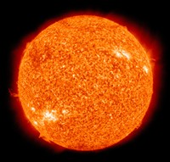](http://planetfacts.org/facts-about-the-sun/) [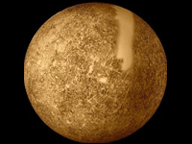](http://planetfacts.org/planet-mercury-facts/)

GROUP 3: Venus GROUP 4: Earth

[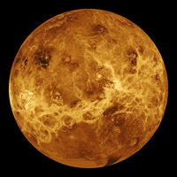](http://planetfacts.org/planet-venus-facts/) [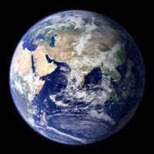](http://planetfacts.org/planet-earth-facts/)

C:\Users\Catlin\AppData\Local\Microsoft\Windows\Temporary Internet Files\Content.IE5\SCC510EA\MC900230925[1].wmf

“Strangers, from the blue planet!”

GROUP 5: Mars GROUP 6: Jupiter

[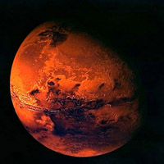](http://planetfacts.org/planet-mars-facts/) [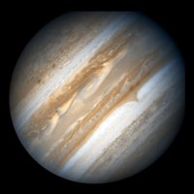](http://planetfacts.org/planet-jupiter-facts/)

GROUP 7: Saturn GROUP 8: Uranus

[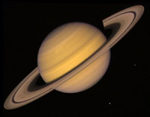](http://planetfacts.org/planet-saturn-facts/) [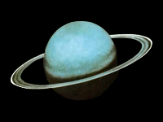](http://planetfacts.org/planet-uranus-facts/)

GROUP 9: Neptune GROUP 10: Pluto

[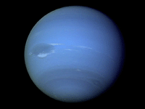](http://planetfacts.org/planet-neptune-facts/) 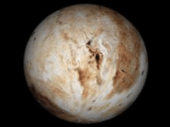[](http://www.youtube.com/watch?v=NJw9Rog97m4)Wanna find out why Pluto is not considered a planet anymore? Follow me and find out!

Step 2

The next step is to return to Earth with the data you have collected and begin creating your models of the places you visited. Make sure your worksheets are complete. Keep in mind that you are still in your groups, and must work together.

Your instructor will provide you with the materials you will need to create your model planet or sun which will be an assortment of:

* Styrofoam balls
* Markers, crayon, pencils
* Felt
* Egg cartons (to make mountains)
* Glue
* Play Dough
* Duck Tape

Your models do not have to be to scale! It is your estimation based on your research. For example if you have the sun, do not make it the smallest model. Do your best to create your models and use your imaginations! Base your models on what you learned. In your presentations, give the class a reason why you used egg cartons for your particular planet. The reason being your planet has lots of mountains.

Use the links Buzz Lightyear provides below to help give you ideas and inspirations! (The second video shows some great, detailed pictures.)

[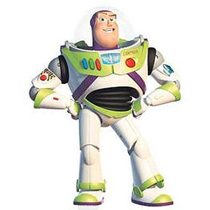](http://www.youtube.com/watch?v=mzca6TBwVCE&feature=related) [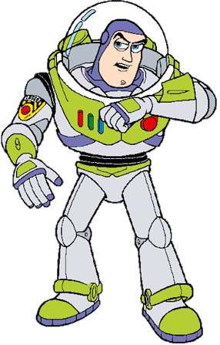](http://www.youtube.com/watch?v=zWpZ1gIEHhY&feature=related)

Step 3:

The final phase is to present your celestial body that you explored with your group, and you must list all the information you and your fellow explorers gathered. All explorers must speak up!

Steps to present:

1. Group must be in front of the classroom with one of the presenters holding up their model.
2. Presenters will explain the information on their worksheets, especially planet ranking from largest to smallest, planet’s diameter, and how far this planet is away from the Earth.
3. Presenters will explain how they created their models and why they used the materials they used.
4. Every person must turn in the worksheets when finished.

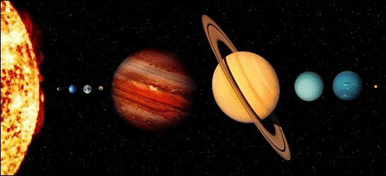

**Evaluation:**

Explorers, you will be receiving two grades which will be averaged together. Your research worksheet will be counted as one independent project, and the presentation will be counted as your group project grade. Average those together, and you will have your grade.

**RUBRIC FOR INDEPENDENT WORKSHEET**

|  |  |  |  |
| --- | --- | --- | --- |
|  | Beginning | Developing | Accomplished |
| Correct Information | Student showed lack of understanding of the information they researched. The worksheet had 5 or more incorrect answers. | Student mostly shows understanding of the information they researched. The worksheet had up to 2 or 3 incorrect answers | Student shows clear understanding of the information they researched. The worksheet had 1 to no errors.. |
| Completeness | Student has 5 or more incorrect answers | Student has 8 to 7 answers filled in correctly. | Student has 9 to 10 answers filled in correctly. |

**RUBRIC FOR GROUP PRESENTATION**

|  |  |  |  |
| --- | --- | --- | --- |
|  | Beginning | Developing | Accomplished |
| Information Presented | Students present little acquired information about the topic. Presentation limited to only facts about diameter, distance from Earth, and planet ranking.  4 or more mistakes. | Students present mostly correct information. Presented facts about diameter, distance from Earth, and planet ranking. Had some other important information on the topic. 2 to 3 mistakes. | Students present accurate information on the topic assigned. Presented facts about diameter, distance from Earth, planet ranking, and other important information. 1 to no mistakes |
| Model | Students create a model in which almost no characteristics are shown about the celestial body. Almost no creativity | Students create a model which shows most of the characteristics of the celestial body. Creativity slightly lacking | Students create a model which distinctly shows characteristics about the celestial body covered. Good, creative use of materials. |
| Participation | Only one student gave input. | Every student gave input, but some more than others. | Every student in the group gave a good amount input to the topic. |
| Behavior | Students show poor respect to the one speaking, and have to be reminded to keep quiet. | Students take turns speaking mostly, but some do act out | Students wait for each other to speak in the group, and take turns speaking. No one is rude to the speaker by acting out. |

**Conclusion:**

Calling all space explorers! You did it! You completed your mission. Each one of you went off into space to discover distances and characteristics of each of the planets and the sun in our Milky Way Galaxy. You returned back to Earth to tell your fellow explorers what you had learned from your adventure by completing the data worksheets, building your models, and presenting all you have learned.

THE LESSON IS COMPLETE! CONGRATUALTIONS! You have successfully traveled through space.

[](http://www.youtube.com/watch?v=xvX_5ym_ajI)

Click on the picture above to CELEBRATE!

**WANT TO DISCOVER MORE?** C:\Users\Catlin\AppData\Local\Microsoft\Windows\Temporary Internet Files\Content.IE5\FDYFX6QM\MC900295694[1].wmf

Below are some fun, interactive, and helpful links to discovering more about our solar system.

[SOLAR SYSTEM TRADING CARDS](http://amazing-space.stsci.edu/resources/explorations/trading/)- Need some extra practice on remembering planet characteristics? In this game, collect the trading cards by selecting the correct answers. The more you gain, the more knowledge you will get!

Find out how old you are on other planets!-[AGE CALCULATOR](http://www.solarviews.com/eng/edu/age.htm)

[WEIGHT CALCULATOR](http://www.solarviews.com/eng/edu/weight.htm)- Would you weigh 20 or 200 pounds on Jupiter? Find out here!

Check out this video comparing our solar system celestial bodies to see how small we really are-[PLANET SIZES VIDEO](http://www.youtube.com/watch?v=HEheh1BH34Q)

**Credits:**

(In the order that they appeared)

Solar system photo-http://www.universetoday.com/wpcontent/uploads/2008/04/solarsystem1.jpg

Spaceship earth photo- Clipart

Astronaut photo- Clipart

Solar System photo- Clipart

Solar System Power Point-http://teachertube.com/viewVideo.php?video_id=261743&title=Solar_Systen

Buzz Lightyear Picture- <http://www.homiesonfire.com/buzzlightyear/BuzzLightyear.gif>

Planet Worksheet Link -http://img.docstoccdn.com/thumb/orig/74198384.png

Sun link and photo- <http://planetfacts.org/facts-about-the-sun/>

Mercury link and photo- <http://planetfacts.org/planet-mercury-facts/>

Venus link and photo- <http://planetfacts.org/planet-venus-facts/>

Earth link and photo- <http://planetfacts.org/planet-earth-facts/>

Mars link and photo- <http://planetfacts.org/planet-mars-facts/>

Jupiter link and photo- <http://planetfacts.org/planet-jupiter-facts/>

Saturn link and photo- <http://planetfacts.org/planet-saturn-facts/>

Uranus link and photo- <http://planetfacts.org/planet-uranus-facts/>

Neptune link and photo- <http://planetfacts.org/planet-neptune-facts/>

Pluto link and photo- <http://planetfacts.org/planet-pluto-facts/>

Small alien photos – Clipart

Pluto Video- <http://www.youtube.com/watch?v=NJw9Rog97m4>

Buzz Lightyear photo- <http://thepoliticalcarnival.net/wp-content/uploads/2012/01/buzz-lightyear.jpg>

Solar System Model Link-http://www.youtube.com/watch?v=mzca6TBwVCE&feature=related

Buzz Lightyear photo-

<http://www.silvitablanco.com.ar/toystory/new-11/buzz_lightyear_intercomunicador.gif>

Solar System Planet Link- <http://www.youtube.com/watch?v=zWpZ1gIEHhY&feature=related>

Solar System Photo- <http://coolcosmos.ipac.caltech.edu/cosmic_kids/learn_sirtf/images/solarsystem.gif>

Muppets in Space photo- <http://images.fanpop.com/images/image_uploads/Muppets-From-Space-the-muppets-116872_1024_768.jpg>

Celebration Video- <http://www.youtube.com/watch?v=xvX_5ym_ajI>

Astronaut photo- Clipart

Solar System Trading Cards Link- <http://amazing-space.stsci.edu/resources/explorations/trading/>

Age Calculator Link- <http://www.solarviews.com/eng/edu/age.htm>

Weight Calculator Link- <http://www.solarviews.com/eng/edu/weight.htm>

Planet Sizes Video Link- <http://www.youtube.com/watch?v=HEheh1BH34Q>

And of course

MR. PELITERA!

**Teacher Page:**

Teachers, this WebQuest is designed is help students learn more our solar system. After the lesson, they will be able to learn the sizes and composition of our planets, be able to describe the kinds of distances between the planets, and be able to describe to the class what they learned on their trip through space with their teammates, models, and worksheets.

This WebQuest relates to the:

**Sunshine State Standard / Big Idea:**

**Earth in Space and Time-** The origin and eventual fate of the Universe still remains one of the greatest questions in science. Gravity and energy influence the formation of galaxies, including our own Milky Way Galaxy, stars, the planetary systems, and Earth. Humankind’s need to explore continues to lead to the development of knowledge and understanding of the nature of the Universe.

It covers the Benchmark:

**SC.8.E.5.3**

Distinguish the hierarchical relationships between planets and other astronomical bodies relative to solar system, galaxy, and universe, including distance, size, and composition.